Department of Electrical and Computer Engineering

North South University



Senior Design Project

Building a credit card recommender with Scikit-learn and deploying on web using Django framework

**Group Members:**

Sakib Monir (1530964042)

Mubashir Zahid (1610146042)

Mehedi Hasan Shohel (1632371642)

**Faculty Advisor:**

**Dr. Mohammad Ashrafuzzaman Khan**

**Assistant Professor**

**Department of ECE**

**Summer 2021**

**LETTER OF TRANSMITTAL**

May, 2021

To

Dr. Mohammad Rezaul Bari

Associate Professor and Chairman,

Department of Electrical and Computer Engineering,

North South University, Dhaka.

**Subject:** Submission of Capstone Project on "Building a credit card recommender with Scikit-learn and deploying on web using Django framework ".

Dear Sir,

With due respect, we would like to submit our **Capstone Project Report** on " Building a credit card recommender with Scikit-learn and deploying on web using Django framework "as a part of our BSc program. The report deals with building a credit card recommender to recommend credit and debit cards to professionals, students and general people. This project is built on with the combination of machine learning and Django framework. We believe our project will be beneficial for the banking institutions of our nation as this approach to help customers in recommending credit or debit cards to their needs has yet to be seen. The Capstone project was very much valuable to us as it helped us to gain experience from practical field. It was a great learning experience for us. We tried to the maximum competence to meet all the dimensions required for this report.

We will be highly obliged if you are kind enough to receive this report and provide your valuable judgment. It would be our immense pleasure if you find this report useful and informative to have an apparent perspective on the issue.

Sincerely Yours,

Sakib Monir

Department of ECE

North South University, Bangladesh

Mubashir Zahid

Department of ECE

North South University, Bangladesh

Mehedi Hasan Shohel

Department of ECE

North South University, Bangladesh

**APPROVAL**

The capstone project entitled " Building a credit card recommender with Scikit-learn and deploying on web using Django framework " by Sakib Monir (1530964042), Mubashir Zahid (1610146042) and Mehedi Hasan Shohel (1632371642) is approved in partial fulfillment of the requirement of the Degree of Bachelor of Science in Computer Science and Engineering on May, 2021 and has been accepted as satisfactory.

Supervisor:



**Dr. Mohammad Ashrafuzzaman Khan**

Assistant Professor

Department of Electrical and Computer Engineering,

North South University

Dhaka, Bangladesh.

Department Chairman:

**Dr. Mohammad Rezaul Bari**

Associate Professor and Chairman

Department of Electrical and Computer Engineering,

North South University

Dhaka, Bangladesh.

**Declaration**

This is our truthful declaration that the " Building a credit card recommender with Scikit-learn and deploying on web using Django framework " we have prepared is not a copy of any “Capstone Project Report” previously made by any other team. We also express our honest confirmation in support of the fact that the said “Building a credit card recommender with Scikit-learn and deploying on web using Django framework” has neither been used before to fulfill any other course related purpose nor it will be submitted to any other team or authority in future.

Sakib Monir

Department of ECE

North South University, Bangladesh

Mubashir Zahid

Department of ECE

North South University, Bangladesh

Mehedi Hasan Shohel

Department of ECE

North South University, Bangladesh

**ACKNOWLEDGEMENT**

We wish to express our sincere gratitude to our honorable faculty, **Dr. Mohammad Ashrafuzzaman Khan**, for giving us a chance to represent a report on our card recommendation project. He made our work more precious and easy by helping us his level best to make us understand the whole report process and his appreciation and cooperation made our work easier to complete.

We like to thank each other of our group. Everybody did their best to make it possible. Everybody tried to find information as much as possible to make our report the best. The guidance and support received from all the members who contributed to this study was vital for the completion of this work.

We are mostly grateful to our Almighty for making everything with His permission. Without The Almighty’s will, we couldn’t do anything.

We are also grateful to all of those, whom tried to give us guidance and support directly and indirectly in completing this work.

**Abstract**

Bangladesh despite being an emerging economy, do not have many financial advising systems for the general people. Currently we have many options to choose when it comes to credit or debit cards, each with their own reward features. That’s why we want to develop a credit card recommendation system using real bank card data. To do this we created a responsive web application which will take user predilections into account and bring about recommendations for the user. We also used a Location Api that will filter out credit cards that score high in the recommendation. In this research we used the algorithm that gave the best results and was easy to implement, further testing with other algorithms will also be done to enhance the performance and real data from banks was collected to make it more viable for real world use.

Table of Contents

**CHAPTER 1: INTRODUCTION 1**

1.1 Product Perspective 2

1.2 Project Overview 2

1.3 Motivation 2

**CHAPTER 2: LITERATURE REVIEW 3**

**CHAPTER 3: METHODOLOGY 5**

3.1 Workflow 6

3.2 Dataset 6

3.3 Preprocessing 7

3.4 Feature extraction 8

3.5 Machine learning models 9

3.5.1 KNN 9

3.5.2 Naïve-bayes 9

**CHAPTER 4: RESULTS 10**

4.1 Sample inputs 11

4.2 Classification and analysis 13

**CHAPTER 5: CONCLUSION 16**

5.1 Summary 17

5.2 Future Works 17

**APPENDIX 18**

Github Link: 19

**Reference 20**



# CHAPTER 1: INTRODUCTION

In this chapter we are going to discuss our product perspective, our project overview and what is our motivation behind it.

# 1.1 Product Perspective

Bangladesh as a developing country do not have many financial advising systems for consumers. However as a growing economy currently we have many options to choose when it comes to credit or debit cards, each with their reward scheme which are integrated into our other social services. A credit or debit card can award the user rewards for grocery shopping, cash back, loyalty programs, restaurant discounts, travel points and so on. A system for credit card recommendations is therefore hard to build as each card has its own trade off. In general, people search for blog posts or videos to learn about the credit or debit cards. Some people just ask their family and friends for recommendation; however these choices are not based on hard facts and data. We wish to solve this problem by building our recommendation system.

# 1.2 Project Overview

In this project we are developing a credit card recommender to recommend credit and debit cards to professionals, students and general people. We generate the recommendations using machine learning. User is also able to search through the card database with multiple filtering options enabled.

The final product for this project is a responsive web application which will take user preferences into account and generate recommendations with machine learning. For the web application we use python as the backend language and implement the web application using the **MVC**(Model-View-Controller) paradigm along with machine learning concepts.

Previously, a recommender system would have been implemented with a lot of if then statements and hard coding for the user along with many filters according to user preferences. However, taking a machine learning approach we learn from data that which cards might be suitable for a certain user. Since the credit card recommender is a machine learning product first, we will analyze how to implement the ideas of MVC in this context of machine learning.

# 1.3 Motivation

As citizens of Bangladesh we obviously are very eager to contribute in the development of our economy. Our banking sector despite having a somewhat strong infrastructure does not have a good or easy card recommendation system. We believe that our project will have a positive effect in the banking institutions and their customers.



# CHAPTER 2: LITERATURE REVIEW

Regina et al. conducted research using a machine learning method to analyze a bank credit dataset to predict customers' creditworthiness (their ability to pay their loan in the next month) [1]. To find the best match for testing the bank credit dataset, they used 15 different machine learning algorithms on the data set. For their jobs, he took 30000 bank credit data sets. Apart from the Nearest Centroid( accuracy rate- 54%) and GaussianNaive Bayes(accuracy rate-36%), he discovered that the majority of the algorithms perform admirably in terms of accuracy and other performance measurement metrics. Both of these algorithms had an accuracy rate ranging from 76% to more than 80%.



# CHAPTER 3: METHODOLOGY

# 3.1 Workflow

The user fills out his profile, he fills put a form which takes the users input which consists of his whereabouts, the state that he lives in as well as the area, along with his desired features of the credit cards. The selected features will then go through a KNN(k-nearest neighbor algorithm) model which will output a result which will consist of recommended card name, along with the name of the bank.

# 3.2 Dataset

Data collection was done manually as web scraping is too lengthy, and Bangladeshi banks are always changing their data or don’t have the proper filters. We’ll collect real data from different Bangladeshi banks as the preference of bank type and bank ownership. Data about 131 cards offered by various banks were collected.



# 3.3 Preprocessing

To begin with attributes like Card name are separated from the rest of the features as the Model will be trained on the dataset which can influence the final result and Card name is the main classified output. Many features have Boolean values which will be adjusted accordingly. Certain features have value that are not given or in the negative, these were adjusted accordingly.

# 3.4 Feature extraction

**Features Description**

Card type Type of card(credit/debit/prepaid)

Interest Rate Interest charged to user

Max Interest limit Maximum amount of credit that

The card issuer can give

International transaction Checks if valid for foreign transactions

Available

Balance transfer available Allows payment of one credit card with

another card

Dual currency Allows use of credit card both locally

And overseas.

Rewards Availability of numerous rewards like

Buffet discounts, shopping discounts,

Reward airline tickets etc.

# 3.5 Machine learning models

Since this is a Classification problem, we use a multi class classifier. In machine learning, multiclass or multinomial classification is the problem of classifying instances into one of three or more classes.

# 3.5.1 KNN

K-nearest neighbors (KNN) algorithm is a type of supervised ML algorithm which can be used for both classification as well as regression predictive problems. However, it is mainly used for classification predictive problems in industry. K-nearest neighbors (KNN) algorithm uses ‘feature similarity’ to predict the values of new datapoints which further means that the new data point will be assigned a value based on how closely it matches the points in the training set.

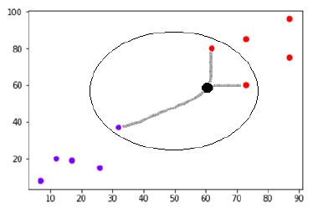

# 3.5.2 Naïve-bayes

The classification technique based on Bayes theorem assumes independence between predictors, thus, the presence of a particular feature in a class is independent of another feature in another class. Naïve bayes classification is based on estimating P(X|Y), the probability or probability of density of features X given class Y



# CHAPTER 4: RESULTS

# 4.1 Sample inputs

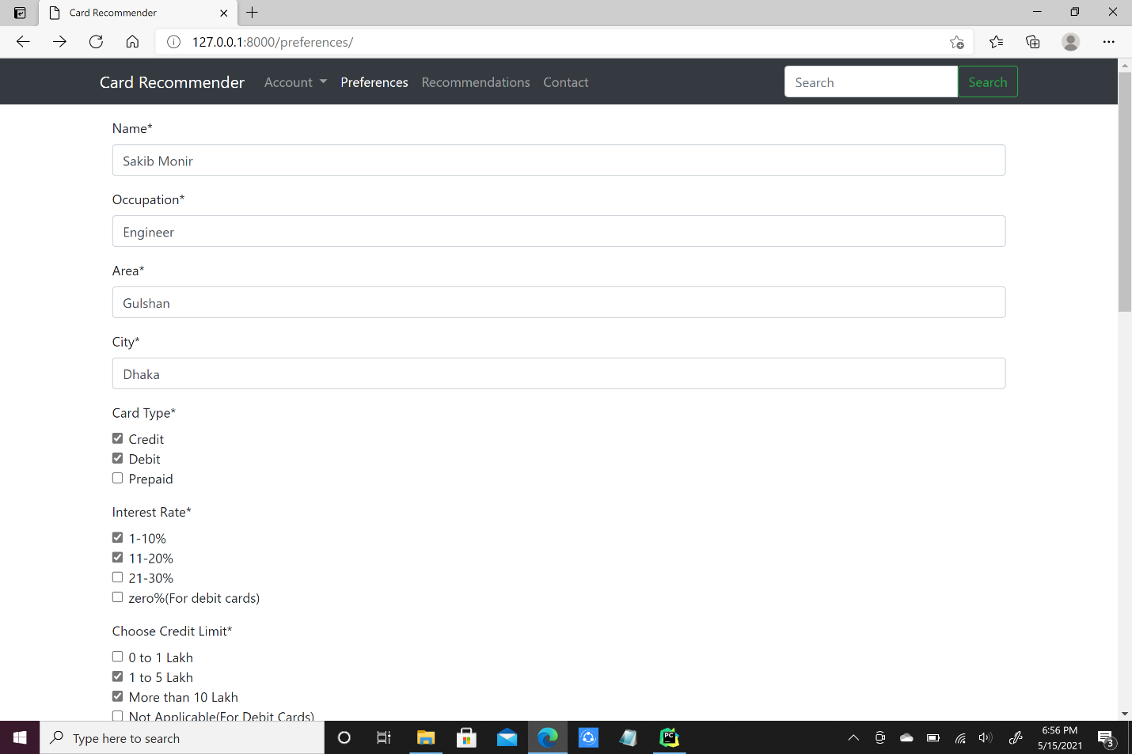

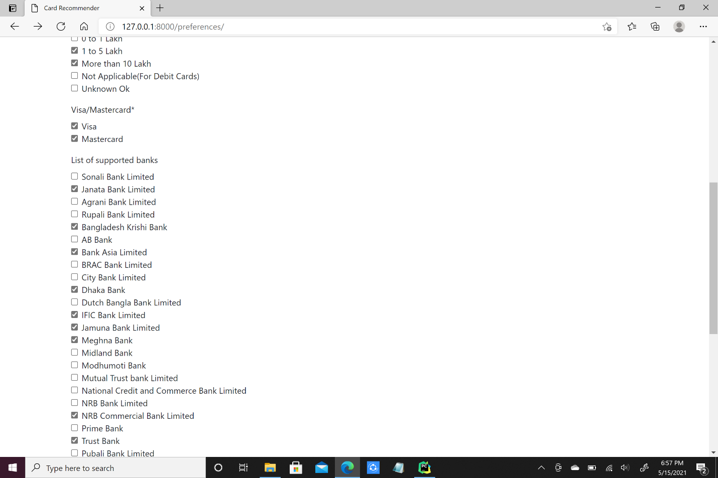

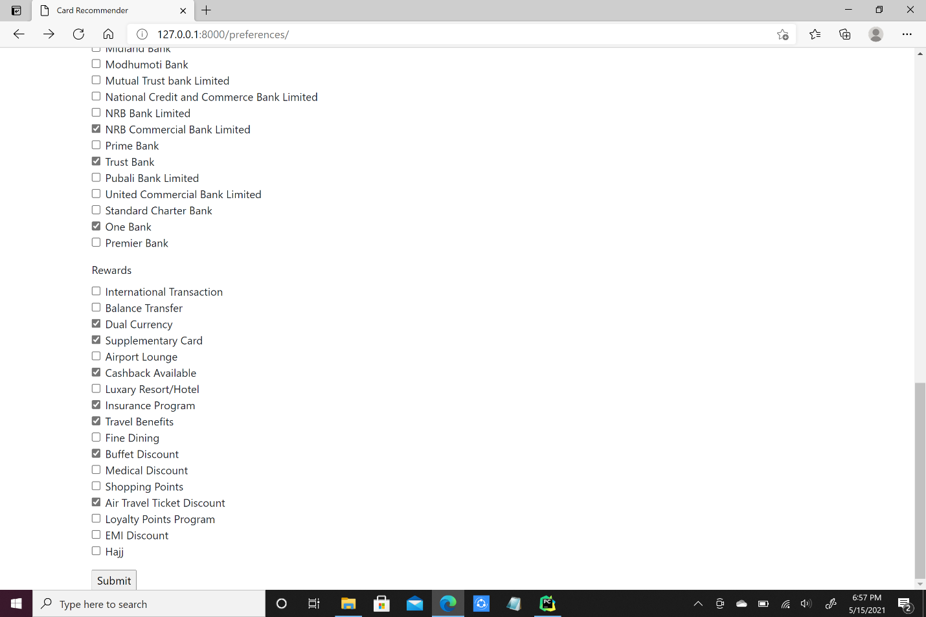

# 4.2 Classification and analysis

We fed our input to the classifier and this is the result.

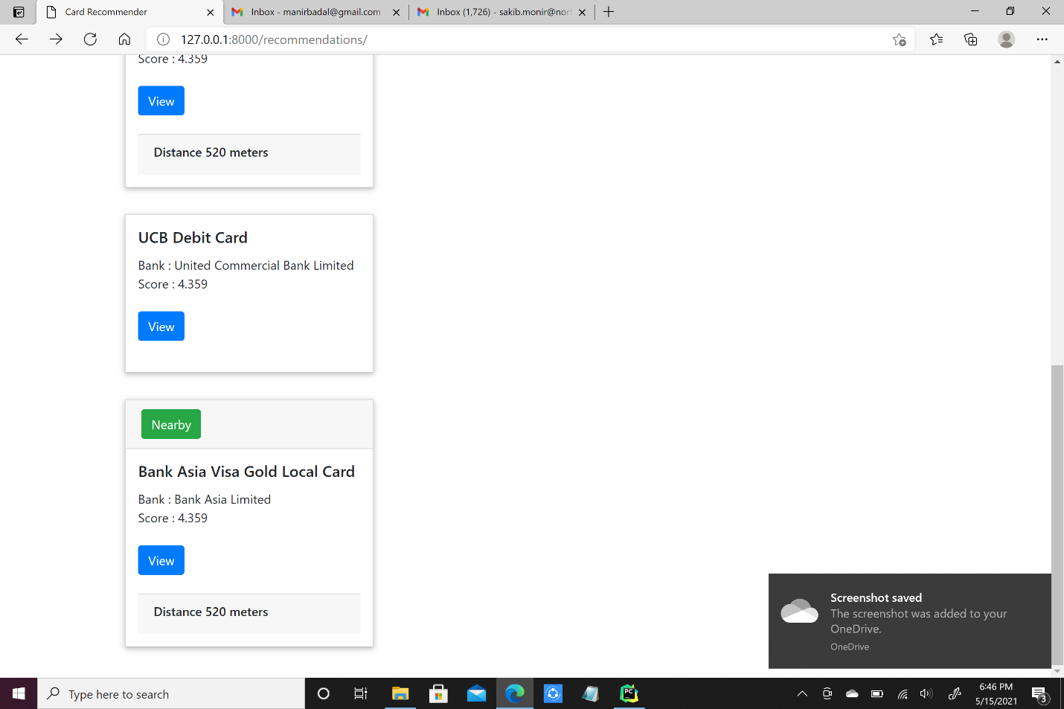

The score of the cards are given out of 5, the higher the score the more it met the users preference features, we also used a location Api to measure the distance of the bank to the area of residence of the user.

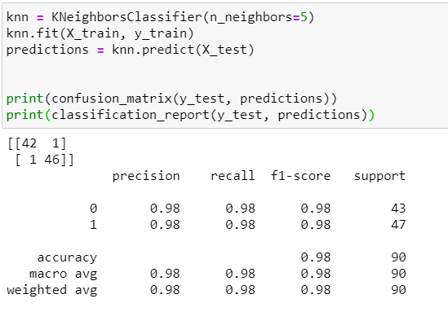



# CHAPTER 5: CONCLUSION

In this chapter, we will discuss on the challenges we faced in this project and make it better and further developments in the future.

# 5.1 Summary

Bangladesh and the rest of the world have a growing cashless economy. Grocery shops, electronic companies, hotels, resorts and restaurant all offer discounts based on the card that is being used for payment. Thus, to better the user experience, its prime time for making a credit card recommendation system.

# 5.2 Future Works

If we decide to work on the paper, we want to use more algorithms like neural networks, Random forest and SVM to test and improve the overall accuracy of our project. Also, we would want to collect more data to make it more viable for real world use.



# APPENDIX

## Github Link:

[**https://github.com/MubashirZahid/CSE-498-Project**](https://github.com/MubashirZahid/CSE-498-Project)

# Reference

1. (PDF) A machine learning approach for predicting bank creditworthiness. Available from: [https://www.researchgate.net/publication/309151303_A_machine_learning_approach_for_predicting_bank_credit_worthiness?fbclid=IwAR0AHZxyxOqZtvJVdaPlkEwTEIlylPwLjenZwxotouQsoW0PU1hk-fm3WVk](https://www.researchgate.net/publication/309151303_A_machine_learning_approach_for_predicting_bank_credit_worthiness?fbclid=IwAR2I9xDDXEBWTQzBqc8aqO8PlE_RvfX1mMAst_GwjwLMiwcRB2J3weHFxjs)